**Tourism Management**

A Project-II Report

Submitted in partial fulfillment of requirement of the

Degree of

**BACHELOR OF TECHNOLOGY in COMPUTER SCIENCE & ENGINEERING**

BY

**Pranay Garg**

**[EN18CS301175]**

Under the Guidance of

**Dr. Kailash C Bandhu**

**Mr. Binod K Mishra**



**Department of Computer Science & Engineering**

**Faculty of Engineering**

**MEDI-CAPS UNIVERSITY, INDORE- 453331**

**April, 2022**

**Report Approval**

The project work **“Tourism Management”** is hereby approved as a creditable study of an engineering/computer application subject carried out and presented in a manner satisfactory to warrant its acceptance as prerequisite for the Degree for which it has been submitted.

It is to be understood that by this approval the undersigned do not endorse or approved any statement made, opinion expressed, or conclusion drawn there in; but approve the “Project Report” only for the purpose for which it has been submitted.

Internal Examiner

Name:

Designation

Affiliation

External Examiner

Name:

Designation

Affiliation

**Declaration**

I/We hereby declare that the project entitled **“Tourism Management”** submittedin partial fulfillment for the award of the degree of Bachelor of Technology in Computer Science’ completed under the supervision of **Dr. Kailash Bandhu, Computer Science & Engineering** Faculty of Engineering, Medi-Caps University Indore is an authentic work.

Further, I/we declare that the content of this Project work, in full or in parts, have neither been taken from any other source nor have been submitted to any other Institute or University for the award of any degree or diploma.

**Pranay Garg [EN18CS301175]**

**Certificate**

I/We, **Dr. Kailash Bandhu** certify that the project entitled **Tourism Management”** submittedin partial fulfillment for the award of the degree of Bachelor of Technology by **Pranay Garg** istherecordcarried out by him/them under my/our guidance and that the work has not formed the basis of award of any other degree elsewhere.

________________________________

**Dr. Kailash Bandhu**

Computer Science & Engineering

Medi-Caps University, Indore

________________________________

<Name of External Guide (If any)>

<Name of the Department>

Name of the Organization

_____________________

Dr. Pramod S. Nair

Head of the Department

Computer Science & Engineering

Medi-Caps University, Indore

**Offer Letter of the Project work-II/Internship**

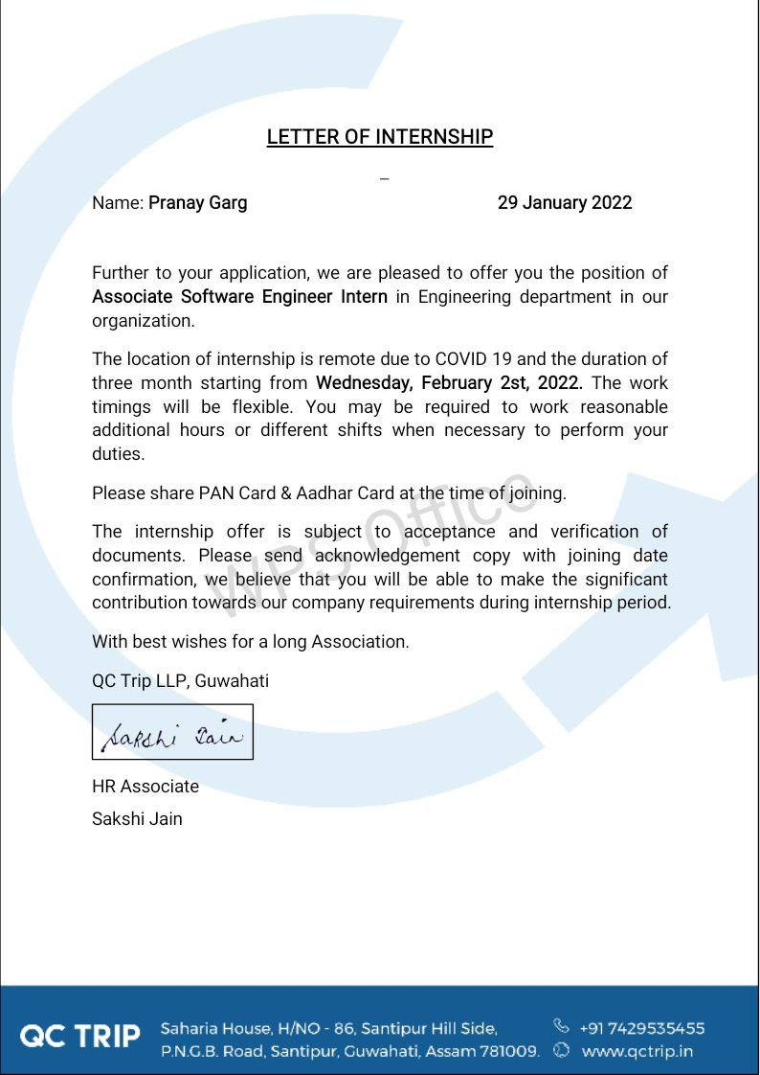

**Completion certificate/Letter**



**Acknowledgements**

I would like to express my deepest gratitude to Honorable Chancellor, **Shri R C Mittal,** who has provided me with every facility to successfully carry out this project, and my profound indebtedness to **Prof. (Dr.) Dilip K Patnaik,** Vice Chancellor, Medi-Caps University, whose unfailing support and enthusiasm has always boosted up my morale. I also thank **Prof. (Dr.) D K Panda,** Pro Vice Chancellor, **Dr. Suresh Jain,** DeanFaculty of Engineering, Medi-Caps University, for giving me a chance to work on this project. I would also like to thank my Head of the Department **Dr. Pramod S. Nair** for his continuous encouragement for betterment of the project.

I express my heartfelt gratitude to my **External Guide, Mr. Manoj Kumar**, Project Lead, Honeywell Technology Solutions Lab Pvt. Ltd as well as to my Internal Guide, Dr**. Debendra Kumar Panda,** Professor, Department of Electronics Engineering, MU, without whose continuous help and support, this project would ever have reached to the completion.

I would also like to thank to my team at Honeywell Mr. Kishore Sandrana, Mr .Gaurav Vashisth, Mr. Jayaprakash Vendkadabathi, Ms. Shabna Vasudevan, Mr. Rajesh Kumar, Mr. Gopi Badarla, Ms. Asha Kuriakose who extended their kind support and help towards the completion of this project.

It is their help and support, due to which we became able to complete the design and technical report. Without their support this report would not have been possible.

***Student may write as per their experience.***

**Pranay Garg**

B.Tech. IV Year

Department of Computer Science & Engineering

Faculty of Engineering

Medi-Caps University, Indore

**Abstract**

Most of the people in this world like to travel from one place to another no matter whether it is a small or large distance. The need for a tourism management system that can manage tourism information with ease is sought after by every tour management company. Tour Management system is a dynamic website for tourism business. This travel and tourism application is designed for travel agencies by which they can manage different tour packages based on the destinations. By using this, the tour company can tailor tour packages spanning various destinations at almost every price point. The also implemented search module allows the administrator to find and update or upgrade the tour packages with ease. This module can also even be extended to a customer application page by which customers can find the right tour package for them at every budget, depending on the tour locations. The main purpose is to help tourism companies to manage tour packages. The system can also be used for both professional and business trips. The proposed system maintains a centralized repository to make necessary travel arrangements and to retrieve information easily

**Table of Contents**

|  |  |  |
| --- | --- | --- |
|  |  | **Page No.** |
|  |  |  |
|  | Report Approval | ii |
|  | Declaration | iii |
|  | Certificate | iv |
|  | Offer Letter of the Project work-II/Internship | v |
|  | Completion letter/certificate | vi |
|  | Acknowledgement | vii |
|  | Abstract | viii |
|  | Table of Contents | ix |
|  | List of figures | x |
|  | List of tables | xi |
|  | Abbreviations | xii |
|  | Notations & Symbols | xiii |
| Chapter 1 | Introduction (Whichever is applicable) |  |
|  | 1.1 Introduction | 1 |
|  | 1.2 Literature Review |  |
|  | 1.3 Objectives |  |
|  | 1.4 Significance |  |
| Chapter 2 | Product Information | 4 |
|  | 2.1 Product Information |  |
|  | 2.2 System Analysis and Design |  |
|  | 2.3 Requirement Analysis |  |
|  | 2.3.1 Functional Requirement |  |
|  | 2.3.2 Non-Functional Requirement |  |
|  | 2.4 External Interface Requirement |  |
| Chapter 3 | Feasibility Study | 8 |
|  | 3.1 Operational Feasibility |  |
|  | 3.2 Technical Feasibility |  |
| Chapter 4 | List of Figures | 9 |
|  | 4.1 Definition |  |
|  | 4.2 UML Diagrams |  |
|  | 4.2.1 Use-Case Diagram |  |
|  | 4.2.2 Data Flow Diagram |  |
|  | 4.2.3 State Diagram |  |
|  | 4.2.4 Activity Diagram |  |
| Chapter 5 | Description of Frontend and Backend | 16 |
|  | 5.1 HTML |  |
|  | 5.2 CSS |  |
|  | 5.3 Php |  |
|  | 5.4 MySQL |  |
| Chapter 6 | Testing | 23 |
| Chapter 7 | Implementation | 27 |
| Chapter 8 | Conclusion | 32 |
|  | References and Citations | 33 |

**CHAPTER -1**

**1.1 INTRODUCTION**

Tourism has turned out to be an economic booster contributing to the economic development of many countries over the last few decades. People see holidays as a necessity, and not as luxury in the present scenario. Tourism calls for coordination and cooperation between travel agents, tour operators, and tourists.

Tourism has a few major elements − destinations, attractions, sites, accommodation, and all ancillary services. The need for a robust and dynamic tour management application has been around since the advent of the tourism concept. Thus we have developed an application to provide the best travelling services to the customers and travel agents. The Tourism Management System provides a search platform where a tourist can find their tour places according to their choices. This system also helps to promote responsible and interesting tourism so that people can enjoy their holidays at their favorable places and develop tourism with different cultures so that they enrich the tourism experience and build pride. The Tourism Management System is a web-based application. The objective of this project is to develop a system that automates the processes and activities of a travel agency. It is tedious for a customer to plan a particular journey and have it executed properly. This project is developed to replace the currently existing system, which helps in keeping records of the customer details of destination as well as payment received.

The proposed system is highly automated and makes the travelling activities much easier and flexible. The users can get the very right information at the very right time. This will increase the trust of the customer in to the tourism company as well. This project is designed with SQL Server as back end. All the data will be stored in the server and in case of any data losing situation, a backup will be available by this server. The details related to every aspect of the tourist will be available separately. The admins just have to click once and all the details will be available to them.

**1.2 Literature Review**

Tourism activities can refer to an extension of a brand–consumer relationship. While growth in many industries is flat, worldwide tourism revenues continue to grow. A literature review is not only a crucial endeavour for any academic research, but also the foundation and inspiration for substantial, useful research. Among extant studies on tourism management (TM), few are on literature review while most are concerned with specific issues or countries/areas. This paper aims to draw up an integrated framework of TM. Little effort has been made to systematically examine the vast TM-related literature so as to facilitate better understandings of TM. To eliminate the gap among the extant studies and develop the TM trajectory, a content analysis was undertaken using keywords “TM” in 5 online electronic databases from 1990 to 2013. Based on 773 articles, we discovered the number of publications on TM has significantly increased since 2000 and a steady growth since 2008. While 773 articles are scattered across 196 journals, most appeared in 11 academic journals. We also categorize articles into 10 conceptual groups based on a proposed conceptual framework. The main contribution is to provide a conceptual framework incorporating keyword indexes to operationalize the coverage of TM.

**1.3 Objective**

Project used to automate all process of travel and tourism, book the tour from anywhere in world with single dynamic website. Easiest platform allow user to access all details such as locations, events. Convenience and secure way of travelling. With e-ticketing, all associated information stored digitally. Enables all travel related information operations.

**1.4 Significance**

This application is develop to provide best travelling services to the customers and travel agents. We have developed tours and travel management system to provide a search platform where a tourist can find their tour places according to their choices. This system also helps to promote responsible and interesting tourism so that people can enjoy their holidays at their favorable places. This system also helps to develop tourism with different cultures so that they enrich the tourism experience and build pride. We develop this system to create and promote forms of tourism that provide healthy interaction opportunities for tourists and locals and increase better understanding of different cultures, customs, lifestyles, traditional knowledge and believes. This system also provide a better way to connect with various events.

This system also gives tours related information like which places are tourist attractions, cities, and provinces. Tourist can also get the Map and navigation system and temperature and weather information. Tourist can also book tours through our tours and travels management system. This system also keeps a history of visited places of its users.

**CHAPTER -2**

**2.1 Product Information:**

**2.1.1 Product Perspective:**

The Travel and Tourism Management System is a new self-contained software product that replaces the current manual and visiting processes for finding touring destination. It is aimed for the travel agency where they want to automate their process of storing records. It is a web based application in which system admin can record the customer’s information in the system easily, securely and efficiently. Since manager has all the information related to travel package as well as customers, the travel agency can easily track the appropriate destination according to customer will and book it. It can even generate the reports about the customers and their destination. This system will help the travel agency to manage their large data and to perform day-to-day activities more quickly, securely and efficiently.

**2.1.2 Product Functions** The product functions of Travel Management System are:

* Manage System user, customer.
* Create and publish Tours.
* Login and signup
* Update and manage package

**2.2 System Analysis and Design**

To design the system the project team chooses Object Oriented Modelling techniques and Unified modelling language tools. Because, modification of the object implementation is easy and understanding of the structure is easy and also direct manipulation of architectural components is easy. It also manages and assembles objects that are implementing in our system, and the composition of objects and interaction between objects on the system. This is categorized in to two phases. These phases are object oriented analysis and object oriented design.

**2.3 Requirement Analysis**

**2.3.1 Functional Requirements:**

**2.3.1.1 Admin Requirements:**

* The admin can add new packages.
* The admin can update any package.
* The admin can delete any package.
* The admin can search any package
* The admin can also change his name or password from the dashboard settings.

**2.3.1.2 End User Requirements:**

* The end users book tour plan according to their choice.
* User share their feedback with comments.
* The user can sign up after filling all the fields mentioned in the sign up form.
* The user can login after validation of his/her details from the database.
* The end users can reserve their seats for tour plan which they choose or like.

**2.3.1.3 System Requirements:**

* Travel management system offer logout functionality to end users.
* Travel management system will only accept a valid login details to enroll on a travel Management System in PHP.
* Travel management system will provide password recovery facility.
* Travel management system will redirect the user to whats-app whenever the whats-app icon is pressed for online payment purposes.

**2.3.2 Non-Functional Requirements:**

**2.3.2.1 Performance Requirements**

The system must be interactive, and the delays involved must be less. So, in every action response of the system, there are no immediate delays. In case of scrolling through the menu there should be a delay of no more than 2 second before the next page of menu items is displayed otherwise our people’s dining experience is affected.

**2.3.2.2 Safety Requirements**

There are no possible losses or damage caused by the usage of this system. It does not involve any harm and therefore the users do not have to take any safeguards into consideration while using this project. The model would assist the user in selecting the movie according to taste, as they would be able to select from the top restaurant.

**2.3.2.3 Security Requirements**

The dataset being used for the project is referred from kaggle.com and shouldn’t cause any copyright infringements or breach of personal details.

**2.3.2.4 Software Quality Attributes Availability:**

The system is up and running for most of the time and the server is not down for more than a few minutes to avoid inconvenience of the customers.

**2.3.2.5 Flexibility:**

If need arises in the future, software can be modified to change the requirements.

**2.3.2.6 Portability:**

Software can be easily installed on devices and would run smoothly according to the requirement.

**2.3.2.7 Reusability:**

Current versions can be used in the future versions with more functionality added.

**2.3.2.8 Usability:**

Interface of the software must be easy to use.

**2.4 External Interface Requirements**

**2.4.1 User Interfaces**

This recommendation software has a web-based interface named as “Travel Management System”, which is developed by using HTML, CSS, Bootstrap and Php, in which user can do login/signup and search for different packages and book travel packages.

This is our first page of software where user needs to enter his preferences and after that he will be recommended.

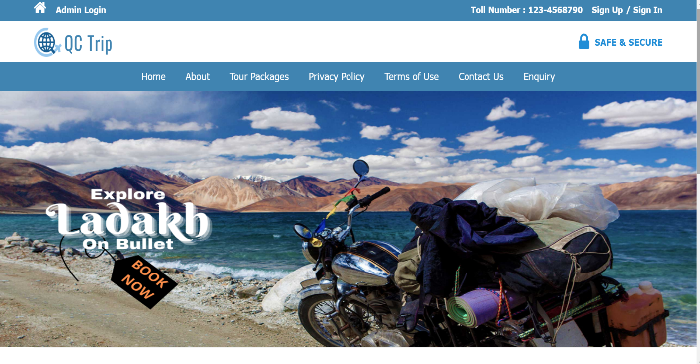

Figure 1: User Interface

**2.3.2** **Hardware Interfaces**

The travel management system can work on any internet connected device having valid internet connection, WIFI or 4G. These devices should have some limit requirements to make the application run effectively. We expect that the processor speed and internet speed is high.

**2.3.3** **Software Interfaces**

First of all, the system will work on any platform. Internet connection is a must to reach the system. Moreover, most of the application will be coded in php.

**2.3.4** **Communications Interfaces**

Communication function required the Internet protocol version 6 and it will follow HTTPS. It will use FTP for the whole system with a local server. This system is a web application; therefore, network connection with TCP/IP protocol is necessary.

**CHAPTER-3**

**FEASIBILITY STUDY**

The following result was obtained while performing a feasibility analysis:

* 1. **Operational feasibility:**

The application used 2-tier architecture. The clients of the applications are the end users who can buy the package different travel packages. The server keeps the records of all users, packages, tickets and the user ratings and responds to the client’s request. The application can be accessed from anywhere with an internet connection. It is easy to use. Thus, it was determined to be operationally feasible.

* 1. **Technical feasibility:**

HTML is used to display content in the browser, CSS to make content look user friendly, and JavaScript for making the web page interactive. At the server side, the logic is implemented using php for dynamic web page generation and to display the predicted result in the browser as well as to handle page requests. A server, client, and internet connection are required to function properly.

**CHAPTER -4**

**LIST OF FIGURES**

**4.1 Definition**

The most creative and challenging face of the system development is System Design. It provides the understanding and procedural details necessary for the logical and physical stages of development. In designing a new system, the system analyst must have a clear understanding of the objectives, which the design is aiming to fulfill. The first step is to determine how the output is to be produced and in what format. Second, input data and master files have to be designed to meet the requirements of the proposed output. The operational phases. Handled through program construction and testing. Design of the system can be defined as a process of applying various techniques and principles for the purpose of defining a device, a process or a system in sufficient detail to permit its physical realization. Thus, system design is a solution to "how to" approach to the creation of a new system. This important phase provides the understanding and the procedural details necessary for implementing the system recommended in the feasibility study. The design step provides a data design, architectural design, and a procedural design.

**4.2 UML Diagrams**

UML, which stands for [Unified Modeling Language](https://www.lucidchart.com/pages/what-is-UML-unified-modeling-language), is a way to visually represent the architecture, design, and implementation of complex software systems. When you’re writing code, there are thousands of lines in an application, and it’s difficult to keep track of the relationships and hierarchies within a software system. UML diagrams divide that software system into components and subcomponents.

UML is a standardized modelling language that can be used across different programming languages and development processes, so the majority of software developers will understand it and be able to apply it to their work.

Though many engineers dread diagrams, they’re useful in an Agile development environment: they keep development [productive and focused](https://www.lucidchart.com/blog/why-developers-should-view-diagrams-as-core-documentation). Instead of thinking them as just a “nice to have,” treat your UML diagrams as core aspects of documentation. UML diagrams can help engineering teams:

* Bring new team members or developers switching teams up to speed quickly.
* Navigate source code.
* Plan out new features before any programming takes place.
* Communicate with technical and non-technical audiences more easily.

**4.2.1 Use Case Diagram**

Use-case diagrams describe the high-level functions and scope of a system. These diagrams also identify the interactions between the system and its actors. The use cases and actors in use-case diagrams describe what the system does and how the actors use it, but not how the system operates internally.

A use case diagram can summarize the details of your system's users (also known as actors) and their interactions with the system. To build one, you'll use a set of specialized symbols and connectors. An effective use case diagram can help your team discuss and represent:

* Scenarios in which your system or application interacts with people, organizations, or external systems
* Goals that your system or application helps those entities (known as actors) achieve
* The scope of your system
  + - 1. **Admin Use Case**

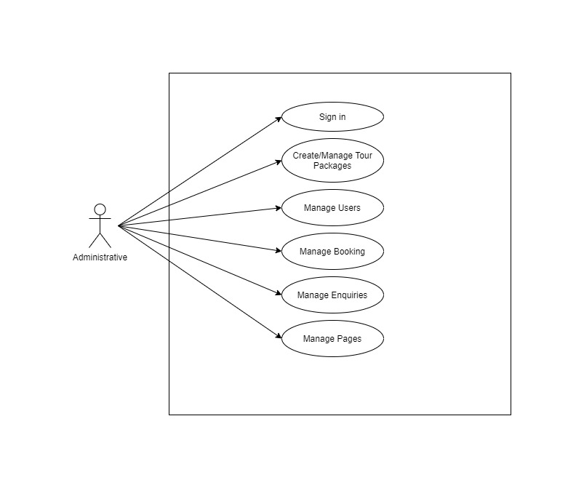

* + - 1. **User Use Case**

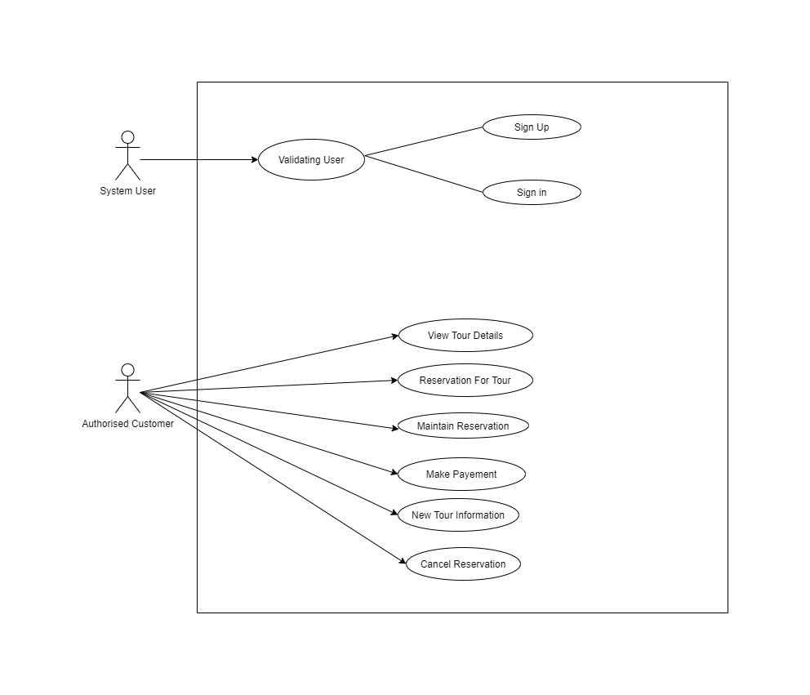

**4.2.2 Data Flow Diagram**

A Data Flow Diagram (DFD) is a traditional visual representation of the information flows within a system. A neat and clear DFD can depict the right amount of the system requirement graphically. It can be manual, automated, or a combination of both.

The objective of a DFD is to show the scope and boundaries of a system as a whole. It may be used as a communication tool between a system analyst and any person who plays a part in the order that acts as a starting point for redesigning a system. The DFD is also called as a data flow graph or bubble chart.

1. All names should be unique. This makes it easier to refer to elements in the DFD.
2. Remember that DFD is not a flow chart. Arrows is a flow chart that represents the order of events; arrows in DFD represents flowing data. A DFD does not involve any order of events.
3. Suppress logical decisions. If we ever have the urge to draw a diamond-shaped box in a DFD, suppress that urge! A diamond-shaped box is used in flow charts to represents decision points with multiple exists paths of which the only one is taken. This implies an ordering of events, which makes no sense in a DFD.
4. Do not become bogged down with details. Defer error conditions and error handling until the end of the analysis.

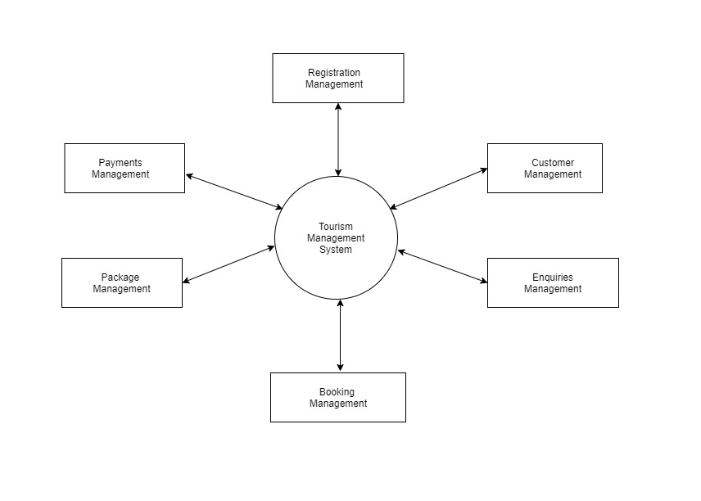

**4.2.3 State Diagram**

A state diagram is a type of diagram used in computer science and related fields to describe the behavior of systems. State diagrams require that the system described is composed of a finite number of states; sometimes, this is indeed the case, while at other times this is a reasonable abstraction.

State diagrams are useful in simplifying the design process of applications that use complex decision-making algorithms. In addition to visualizing the flow of a complex decision-making algorithm, the state diagram is a functional form of application planning.

Identify the initial state and the final terminating states. Identify the possible states in which the object can exist (boundary values corresponding to different attributes guide us in identifying different states). Label the events which trigger these transitions.

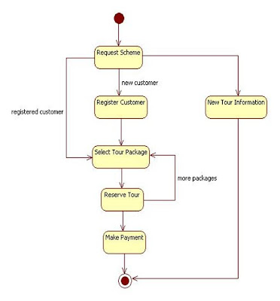

**4.2.4 Activity Diagram**

An activity diagram shows business and software processes as a progression of actions. These actions can be carried out by people, software components or computers. Activity diagrams are used to describe business processes and use cases as well as to document the implementation of system processes.

Activity diagram is basically a flowchart to represent the flow from one activity to another activity. The activity can be described as an operation of the system. The control flow is drawn from one operation to another. This flow can be sequential, branched, or concurrent.

We can depict both sequential processing and concurrent processing of activities using an activity diagram. They are used in business and process modelling where their primary use is to depict the dynamic aspects of a system. An activity diagram is very similar to a flowchart.

Flowcharts were typically invented earlier than activity diagrams. Non programmers use Flow charts to model workflows. For example: A manufacturer uses a flow chart to explain and illustrate how a particular product is manufactured. We can call a flowchart a primitive version of an activity diagram. Business processes where decision making is involved is expressed using a flow chart. So, programmers use activity diagrams (advanced version of a flowchart) to depict workflows. An activity diagram is used by developers to understand the flow of programs on a high level. It also enables them to figure out constraints and conditions that cause particular events. A flow chart converges into being an activity diagram if complex decisions are being made. Brevity is the soul of wit. We need to convey a lot of information with clarity and make sure it is short. So an activity diagram helps people on both sides i.e. Businessmen and Developers to interact and understand systems.

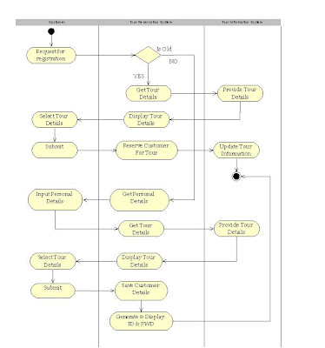

**CHAPTER -5**

**DESCRIPTION OF FRONT END AND BACK END**

**5.1 HYPER TEXT MARKUP LANGUAGE:**

The Hyper Text Markup language (HTML) is a simple markup language used to create hypertext documents that are portable from one platform to another HTML documents are SGML documents with generic semantics that are appropriate for representing information from a wide range of applications. This specification defines HTML version 4.0 HTML 4.0 aims to capture recommended practice as of early '96 and as such to be used as a replacement for HTML. 3.2

**5.1.1 Why to use HTML:**

Web site is a collection of pages, publications and documentation that reside on web server. While these page publication and a document as a formatted in any single format you should use HTML for home page and all primary pages and the site. This will enable the millions of web users it considered first formatting any new material you plan to publish on the web HTML documents are platform independent, meaning that they don't conform to any standard it they are created properly you can more home page to any server platform or you can access them with any complaint www browser.

* <HTML>...</HTML> All HTML files start and end with the tag pair.
* <HEAD>...</HEAD> All HTML have a pair of "HEAD" tags that indicate what the tile and other attributes of the page are going to be.
* <TITLE>...</TITLE>- this tag indicates what the title of the HTML file is going to be on the BROWSER window title.
* <BODY>...<</BODY> - this tag pair is to logically separate the HTML file into the header and the body. Usually, the header contains information regarding the html whereas the body contains information that the HTML file must actually contain.
* The HTML template must look like. <!DOCTYPE HTML PUBLIC "THIS IS AN EXAMPLE">

<HTML>

<HEAD>

<TITLE> YOUR TITLE GOES HERE</TITLE>

</HEAD>

</HTML>

* <P>...</P> This tag pair used to indicate the paragraph. Any text that needs to be separated into a paragraph must be put in within a paragraph tag.
* <B>...</B> - This tag pair is used to indicate the text within tag pair must be in bold letters.
* <P>...</D - This tag pair is used to indicate the text within the tag para must be in italic letters.
* <IMG SRC="./images/corp.gif" ALT=: LOGO" HEIGHT="100" WIDTH="100"> This tag is used to embed images in the HTML pages. The SRC attribute is used to locate the file name under a directory, the ALT attribute is used to indicate the TOOLTIP message that must appear, and HEIGHT and WIDTH indicate the height and the width of the images that is being shown on the HTML pages.

<HI ALIGN="CENTER">

</H1>

* This pair of tags indicate that the text must be main title for the HTML page. The ALIGN attribute can be used to set the alignment to "center" or "left" or "right"

<HI>Heading 1</H1

<H2>Heading2</H2>

<H3>Heading3</H3>- This set of tags will show the Headings in smaller fonts as the heading increases.

* ALIGN The align attribute can be used for headings as well. For
* <P>...</P> tags also, the ALIGN attribute can be used.
* <BR> Used to insert a carriage return in the HTML file. The attribute to be used for this is the CLEAR attribute.
* <CENTER>...</CENTER>To center the entire block of text these tags are used.
* <A>... </A> Anchor Tags. These tags are used linking namely hyper linking.
* Example:
* <A HREF=http://www.ibm.com>Visit IBM Web Pages</A>
* Images Basics: Image Tag is used to embed images in the html document. The general syntax is
* <IMG SRC="logo.gif">
* Tables <TABLE>...<TABLE> This is used to specify the table type of layout in the HTML document.

<TABLE BORDER-"1">

<TR>

<TH>Car</TH>

<TH>Company</TH>

</TR>

<TR>

<TH>Concorde</TH>

<TH>Chrysler</TH>

</TR>

</TABLE>

**5.2 Cascading Style Sheets (CSS)**

* CSS describes how HTML elements are to be displayed on screen, paper, or in other media
* CSS saves a lot of work. It can control the layout of multiple web pages all at once
* External stylesheets are stored in CSS files
* CSS is used to define styles for your web pages, including the design, layout and variations in display for different devices and screen sizes.
* There are three ways of inserting a style sheet:
* External CSS: Each HTML page must include a reference to the external style sheet file inside the <link> element, inside the head section.
* Internal CSS: The internal style is defined inside the <style> element, inside the head section.
* Inline CSS: To use inline styles, add the style attribute to the relevant element. The style attribute can contain any CSS property.
* CSS Colors: background-color, Text Color, Border Color,
* The CSS Box Model: Content - The content of the box, where text and images appear
* Padding - Clears an area around the content. The padding is transparent
* Border - A border that goes around the padding and content
* Margin - Clears an area outside the border. The margin is transparent
* CSS Height and Width : t sets the height/width of the area inside the padding, border, and margin of the element.
* CSS Text : Text Alignment, Text Decoration, Text Transformation
* CSS Layout - Horizontal & Vertical Align: text-align- center, left, right.

**5.3 Hypertext Preprocessor (php)**

* PHP is an acronym for "PHP: Hypertext Preprocessor"
* PHP is a widely-used, open source scripting language
* PHP scripts are executed on the server
* PHP is free to download and use
* PHP can generate dynamic page content
* PHP can create, open, read, write, delete, and close files on the server
* PHP can add, delete, modify data in your database
* PHP can be used to control user-access
* A PHP script can be placed anywhere in the document.
* A PHP script starts with <?php and ends with?>
* PHP statements end with a semicolon
* In PHP, a variable starts with the $ sign followed by the name of the variable
* Echo is used to output the data on the screen
* The echo statement can be used with or without parentheses
* PHP Data Types: Variables can store data of different types, and different data types can do different things, like string, integer, float, Boolean, array etc.
* PHP operators: Operators are used to perform operations on variables and values. Arithmetic, assignment, comparison, logical, condition assignment.
* PHP if...else...elseif Statements: Conditional statements are used to perform different actions based on different conditions.
* PHP function: A Function in PHP is a reusable piece or block of code that performs a specific action. It takes input from the user in the form of parameters, performs certain actions, and gives the output.
* PHP array: An array is a special variable, which can hold more than one value at a time.

**5.3.4 MySQL**

MySQL is an open source relational database management system. For WordPress sites, that means it helps you store all your blog posts, users, plugin information, etc. It stores that information in separate “tables” and connects it with “keys”, which is why it's relational.

A database is a separate application that stores a collection of data. Each database has one or more distinct APIs for creating, accessing, managing, searching and replicating the data it holds.

Other kinds of data stores can also be used, such as files on the file system or large hash tables in memory but data fetching and writing would not be so fast and easy with those type of systems.

Nowadays, we use relational database management systems (RDBMS) to store and manage huge volume of data. This is called relational database because all the data is stored into different tables and relations are established using primary keys or other keys known as Foreign Keys.

A Relational DataBase Management System (RDBMS) is a software that −

Enables you to implement a database with tables, columns and indexes.

Guarantees the Referential Integrity between rows of various tables.

Updates the indexes automatically.

Interprets an SQL query and combines information from various tables.

RDBMS Terminology

Before we proceed to explain the MySQL database system, let us revise a few definitions related to the database.

* Database − A database is a collection of tables, with related data.
* Table − A table is a matrix with data. A table in a database looks like a simple spreadsheet.
* Column − One column (data element) contains data of one and the same kind, for example the column postcode.
* Row − A row (= tuple, entry or record) is a group of related data, for example the data of one subscription.
* Redundancy − Storing data twice, redundantly to make the system faster.
* Primary Key − A primary key is unique. A key value can not occur twice in one table. With a key, you can only find one row.
* Foreign Key − A foreign key is the linking pin between two tables.
* Compound Key − A compound key (composite key) is a key that consists of multiple columns, because one column is not sufficiently unique.
* Index − An index in a database resembles an index at the back of a book.
* Referential Integrity − Referential Integrity makes sure that a foreign key value always points to an existing row.

MySQL Database

* MySQL is a fast, easy-to-use RDBMS being used for many small and big businesses. MySQL is developed, marketed and supported by MySQL AB, which is a Swedish company. MySQL is becoming so popular because of many good reasons −
* MySQL is released under an open-source license. So you have nothing to pay to use it.
* MySQL is a very powerful program in its own right. It handles a large subset of the functionality of the most expensive and powerful database packages.
* MySQL uses a standard form of the well-known SQL data language.
* MySQL works on many operating systems and with many languages including PHP, PERL, C, C++, JAVA, etc.
* MySQL works very quickly and works well even with large data sets.
* MySQL is very friendly to PHP, the most appreciated language for web development.
* MySQL supports large databases, up to 50 million rows or more in a table. The default file size limit for a table is 4GB, but you can increase this (if your operating system can handle it) to a theoretical limit of 8 million terabytes (TB).
* MySQL is customizable. The open-source GPL license allows programmers to modify the MySQL software to fit their own specific environments.

A database is just a structured collection of data that’s organized for easy use and retrieval. For a WordPress site, that “data” is stuff like the text of your blog posts, information for all the registered users at your site, autoloaded data, important settings configurations, etc.

When it comes to storing data in a database, there are different approaches that you can use.

MySQL opts for an approach called a relational database.

With a relational database, your data is broken up into multiple separate storage areas – called tables – rather than throwing everything together into one big storage unit.

Using something called a “key”, you’re able to link the data from these two tables together so that you can manipulate and combine the data in different tables as needed. It’s important to note that a key is not the customer’s name. Instead, you’d use something 100% unique, like a numerical ID number.

**Difference between SQL and MySQL:-**

SQL is a query programming language that manages RDBMS. MySQL is a relational database management system that uses SQL. SQL is primarily used to query and operate database systems. MySQL allows you to handle, store, modify and delete data and store data in an organized way.

**CHAPTER -6**

**Testing**

Testing means the process of analyzing the software item to detect the differences between existing or required condition and evaluate the features of the software items. The thorough testing of the system before release of the software needs to be done vide the various test cases and modes so that the software becomes devoid of bugs and uses minimum space requirements as well as minimum time to perform. The test cases were selected before hand with expected results defined and actual results recorded for comparison. The selection of test cases is done vide "White Box Testing technique to check the internal programming logic and efficiency and vide "Black Box Testing" technique to check software requirement fulfillment with intension of finding maximum number of errors with minimum effort and time.

Although test cases are a design by considering the cyclomatic complexity, conditional test, still the software code is not in its optional form, as all other possible alternative parts in the software are not considered. At the integration level, the software will be passing to the third-party tests which would further enhance the software optimality and efficiency.

**TEST CHARACTERS:**

1. A good test has a high probability of finding an error.

2. A good test is not redundant.

3. A good test should be "best of breed"

4. A good test should be neither too simple nor too complex.

**6.1.1 BLACK BOX TESTING:**

The method of Black Box Testing is used by the software engineer to derive the required results of the test cases:

1. Black Box Testing alludes to test that are conducted at the software interface.

2. A Black Box Test examines some fundamental aspect of a system with little regard for the internal logic structure of the software.

3. A limited number of important logical paths can be selected and exercised.

4. Important data structure can be probed for validity.

Black box testing was performed to find errors in the following categories:

• Incorrect or missing functions.

• Graphics error.

• Errors in data in binary format.

• Error in data in integer format.

• File error.

• Pointer error.

• Memory access error.

• Variable error.

• Performance error.

**6.1.2 WHITE BOX TESTING:**

White Box Testing is sometimes called Glass Box Testing. Using White Box Testing methods the software engineer can derive the following test cases:

1. Guarantee that all independent paths within a module have been exercised at least once.

2. Exercise all logical decisions on their true and false sides.

3. Execute all loops at their boundaries and within their operational bounds.

4. Exercise internal data structures to ensure the validity.

In White Box Testing efforts were made to handle the following:

• Number of input parameters equal to number of arguments.

• Parameters and arguments attributes match.

• Number of arguments transmitted is called modules equal to attributes of parameters...

• Unit system of argument transmitted is called modules equal unit system of parameter.

• Number of attributes and order of arguments to build in functions correct.

• Any references to parameters not associated to build in functions correct.

• Input only arguments altered.

• Global variable definition consistent across module.

• Files attributes correct.

• Format specifications matches I/O specification.

• Files opened before use.

• File closed while working is going on.

• 1/0 errors handled.

• Any textual errors in output information.

**6.1.3 TEST PLAN**

Testing means the process of analyzing a software item to detect the difference between the exiting and required permission and to evaluate the features of the software item. Once the test plan is ready and the test cases are completely designed, different level of testing starts.

**6.1.4 UNIT TESTING**

The unit testing is performed to test the validity of the individual units. This is done in the coding phase with the interactive testing. Thus, it itself constitutes a majority of functionality test for each logical unit.

**6.1.5 INTEGRITY TESTING:**

When all the development of all the units or modules is completed and integrates the integrity test phase is started. In this phase the interface between the modules are tested. This phase basically verifies whether inter module exchange of information and events are as per required system behavior.

**6.1.6 SYSTEM TESTING:**

The system testing phase incorporates the performance stress testing so as to meet the product criteria with respect to the desired bench marks. This is necessary test for highly data intensive product.

Result: The entire system was tested for security measures, flexibility, error recovery and efficiency. The test was successful.

**CHAPTER-7**

**IMPLEMENTATION**

1. **Login Page:**

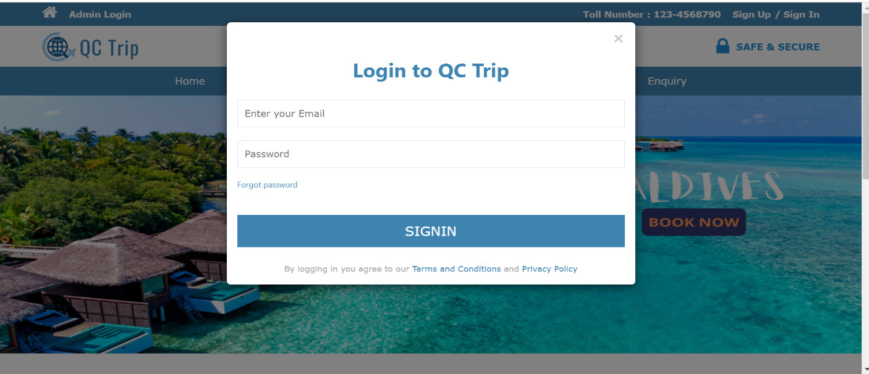

1. **Signup Page**

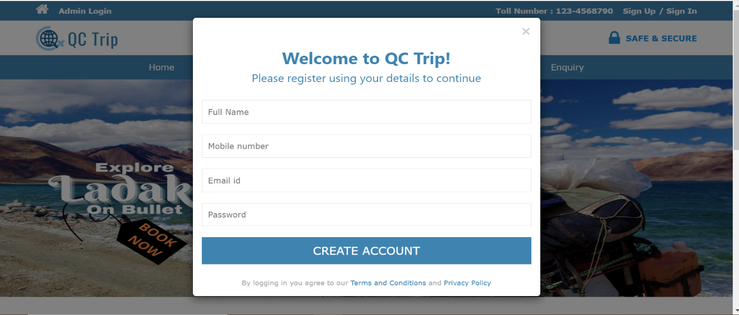

1. **Enquiry Page**

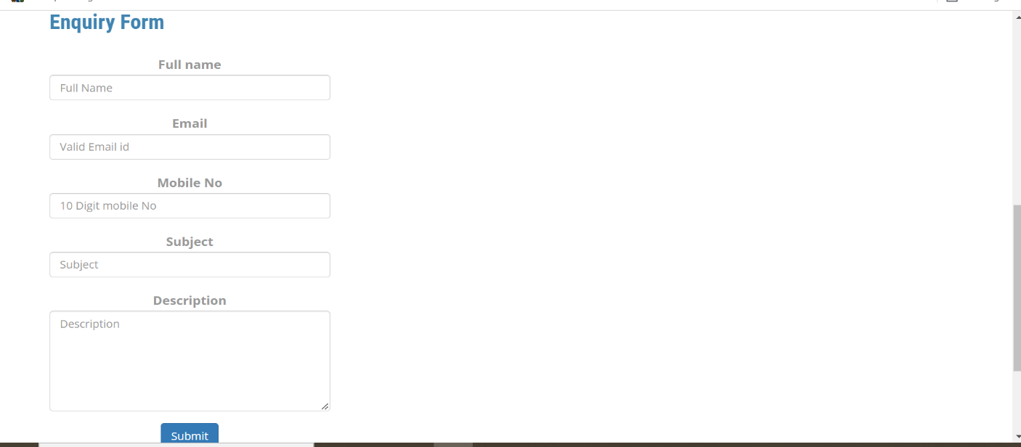

1. **Package Page**

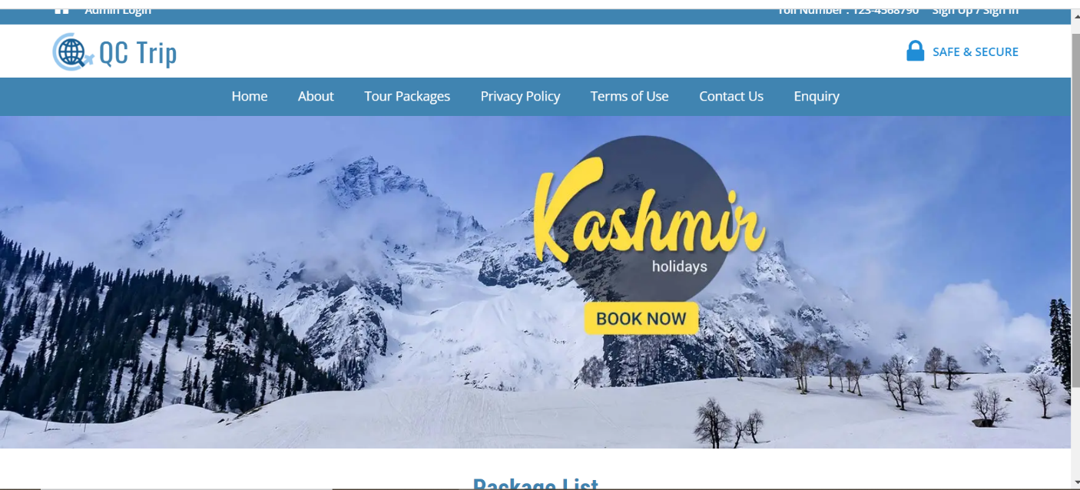

1. **Admin Signin page**

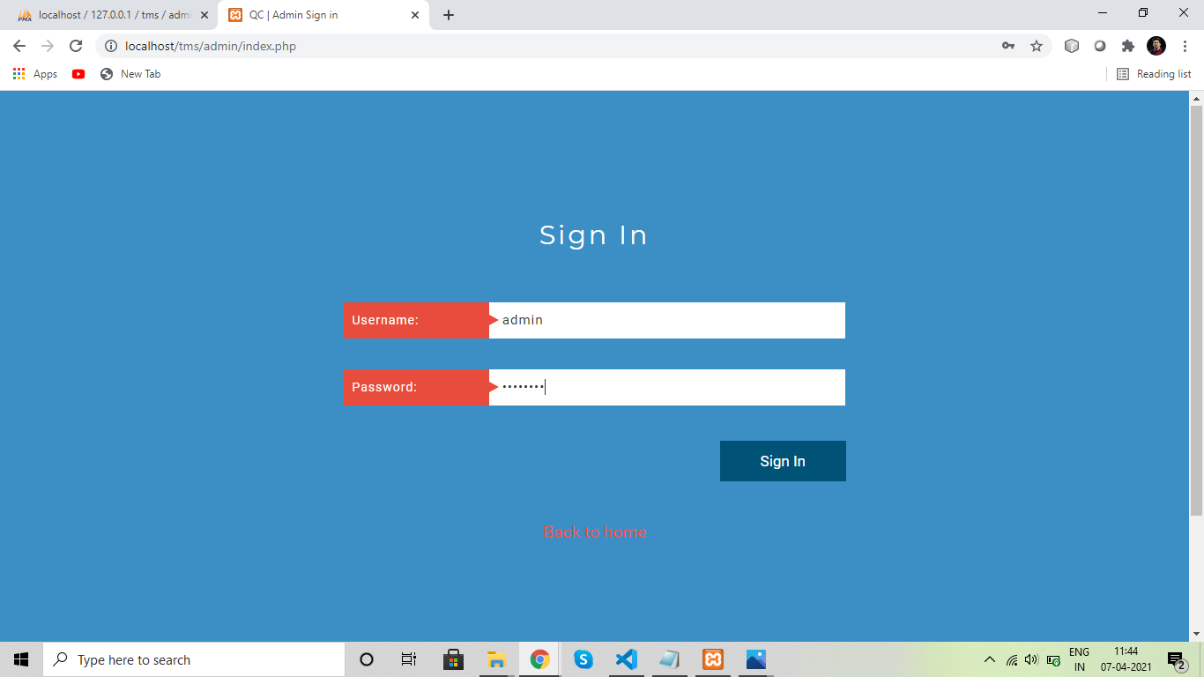

1. **Admin Dashboard**

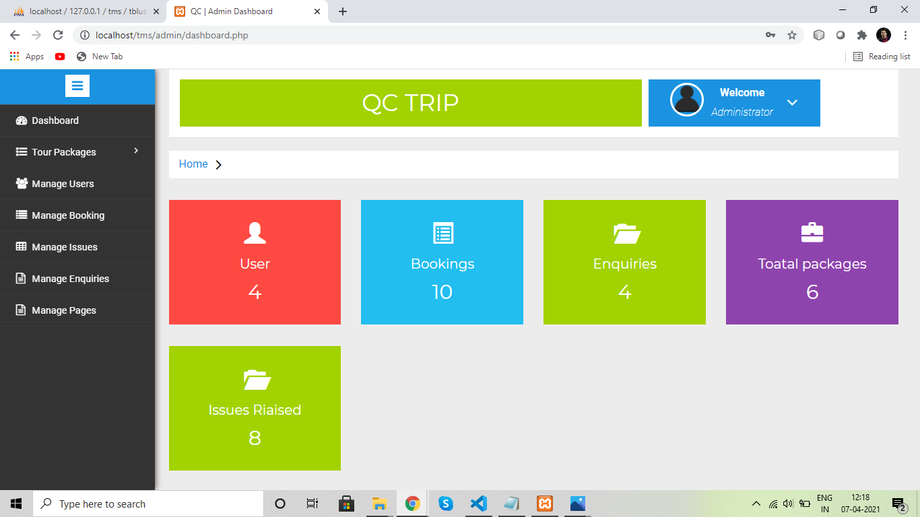

1. **Admin Create Package Page**

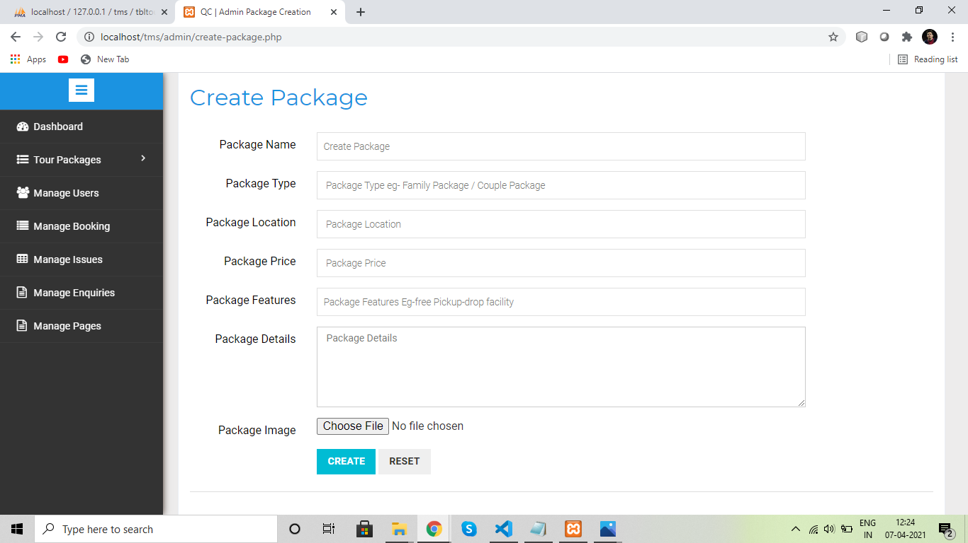

1. **Admin Update Page**

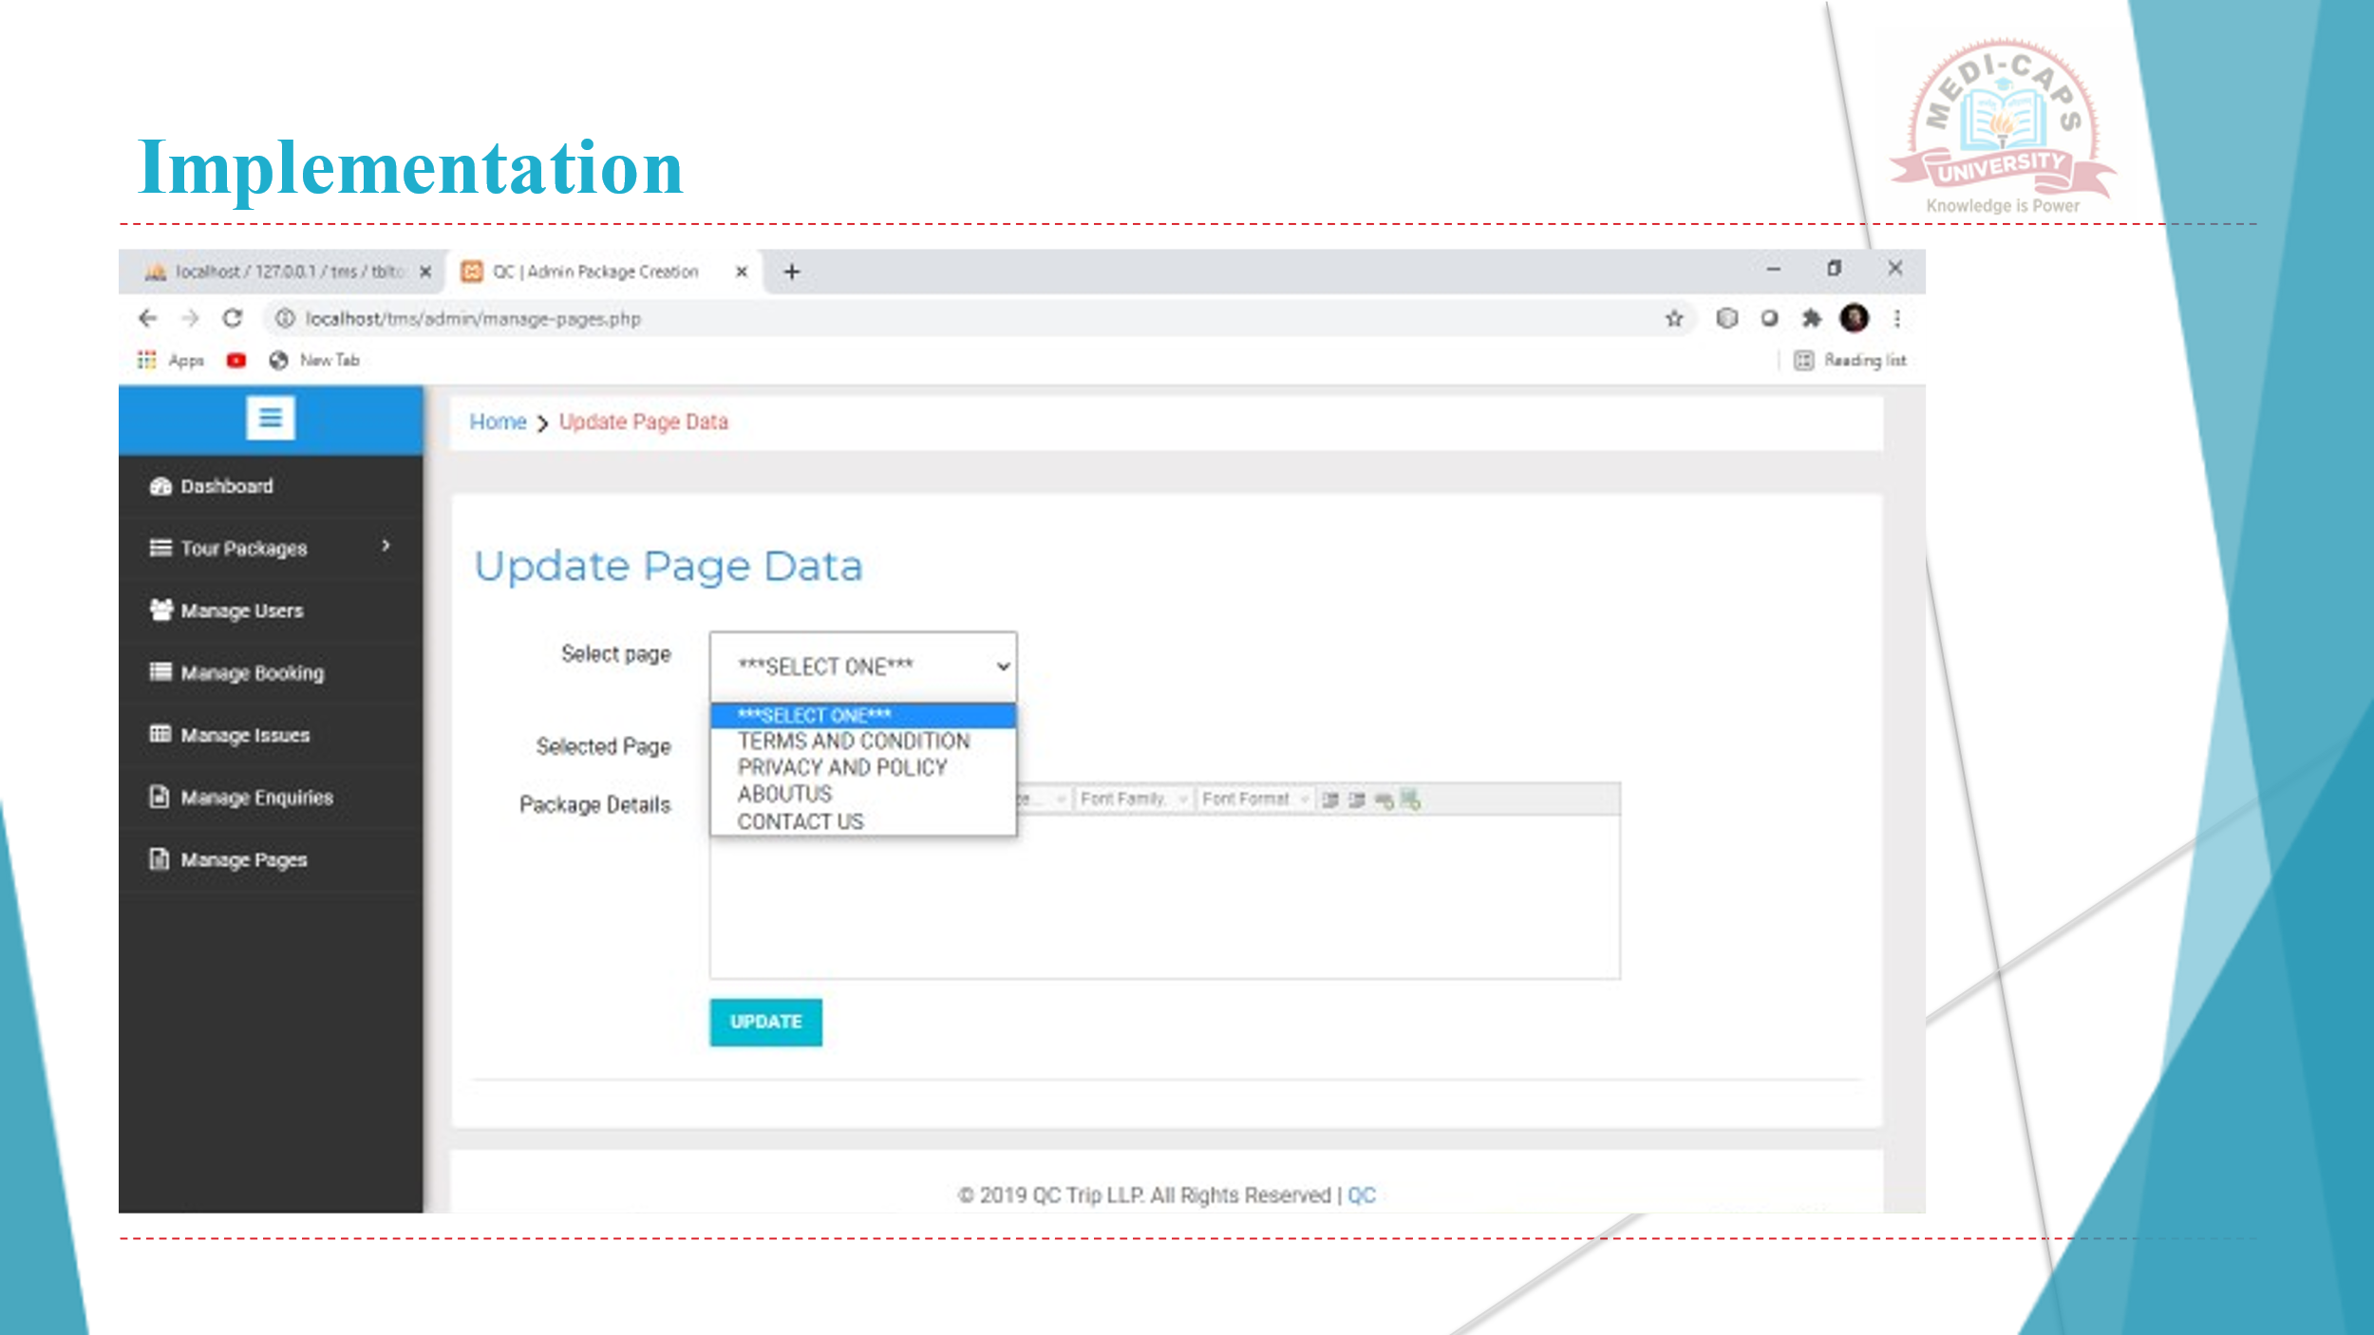

**CHAPTER-8**

**CONCLUSION**

The system has been developed for the given condition and is found working effectively. The developed system is flexible and changes whenever can be made easy. Using the facilities and functionalities of Net, the software has been developed in a neat and simple manner. Thereby reducing the operators work.

The speed and accuracy are maintained in proper way. The user-friendly nature of this software developed is very easy to work with both for the higher management as well as other employees with little knowledge of computer. The results obtained were fully satisfactory from the user point of view.

The system was verified with valid as well as invalid data in each manner the system is run with an insight into the necessary modifications that may require in the future. Hence the system can be maintained successfully without much network.

|  |
| --- |
| References and Citations |

Follow IEEE referencing style for citing the material used in project report. The IEEE reference style for different materials is described below.

|  |  |
| --- | --- |
| **Material Type** | **Works Cited** |
| **Book in print** | [1] D. Sarunyagate, Ed., *Lasers*. New York: McGraw-Hill, 1996. |
| **Chapter in book** | [2] G. O. Young, "Synthetic structure of industrial plastics," in *Plastics*, 2nd ed., vol. 3, J. Peters, Ed. New York: McGraw-Hill, 1964, pp. 15-64. |
| **eBook** | [3] L. Bass, P. Clements, and R. Kazman, *Software Architecture in Practice*, 2nd ed. Reading, MA: Addison Wesley, 2003. [E-book] Available: Safari e-book. |
| **Journal article** | [4] G. Liu, K. Y. Lee, and H. F. Jordan, "TDM and TWDM de Bruijn networks and shufflenets for optical communications," *IEEE Trans. Comp.*, vol. 46, pp. 695-701, June 1997. |
| **eJournal (from database)** | [5] H. Ayasso and A. Mohammad-Djafari,"Joint NDT Image Restoration and Segmentation Using Gauss–Markov–Potts Prior Models and Variational Bayesian Computation," *IEEE Transactions on Image Processing*, vol. 19, no. 9, pp. 2265-77, 2010. [Online]. Available: IEEE Xplore, http://www.ieee.org. [Accessed Sept. 10, 2010]. |
| **eJournal (from internet)** | [6] A. Altun, “Understanding hypertext in the context of reading on the web: Language learners’ experience,” Current Issues in Education, vol. 6, no. 12, July, 2005. [Online serial]. Available: http://cie.ed.asu.edu/volume6/number12/. [Accessed Dec. 2, 2007]. |
| **Conference paper** | [7] L. Liu and H. Miao, "A specification based approach to testing polymorphic attributes," in *Formal Methods and Software Engineering: Proceedings of the 6th International Conference on Formal Engineering Methods, ICFEM 2004, Seattle, WA, USA, November 8-12, 2004*, J. Davies, W. Schulte, M. Barnett, Eds. Berlin: Springer, 2004. pp. 306-19. |
| **Conference proceedings** | [8] T. J. van Weert and R. K. Munro, Eds., *Informatics and the Digital Society: Social, ethical and cognitive issues*: IFIP TC3/WG3.1&3.2 Open Conference on Social, Ethical and Cognitive Issues of Informatics and ICT, July 22-26, 2002, Dortmund, Germany. Boston: Kluwer Academic, 2003. |
| **Newspaper article (from database)** | [9] J. Riley, "Call for new look at skilled migrants," *The Australian*, p. 35, May 31, 2005. [Online]. Available: Factiva, http://global.factiva.com. [Accessed May 31, 2005]. |
| **Technical report** | [10] K. E. Elliott and C.M. Greene, "A local adaptive protocol," Argonne National Laboratory, Argonne, France, Tech. Rep. 916-1010-BB, 1997. |
| **Patent** | [11] J. P. Wilkinson, “Nonlinear resonant circuit devices,” U.S. Patent 3 624 125, Jul. 16, 1990. |
| **Standard** | [12] *IEEE Criteria for Class IE Electric Systems*, IEEE Standard 308, 1969. |
| **Thesis/Dissertation** | [1] J. O. Williams, “Narrow-band analyzer,” Ph.D. dissertation, Dept. Elect. Eng., Harvard Univ., Cambridge, MA, 1993. |